OCEANA COUNTY 4-H SMALL MARKET ANIMAL
EDUCATIONAL RECORD BOOK - 2024

Young beef & feeder calf project
(ages 8 and up)

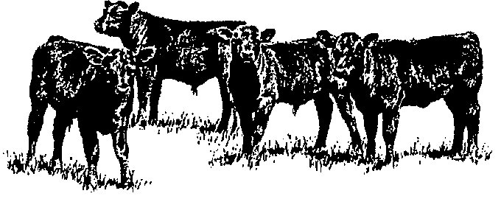

If you are a little buddy check here: _____

My big buddy is: _________________________________________

As a member of the Small Market Animal Project, you are required to submit your records as part of an educational project notebook in order to show your animal at the Oceana County Fair. This notebook must be shown to the Oceana County 4-H Market Livestock Committee's Weighmaster at the time of weigh-in and then entered by you in the Educational Notebook Division of the Oceana County Fair on Entry day.

AGE: _____
The age you enter depends on how old you were on January 1, 2024.

Number of years in project: _____

Use this sheet as the first page of your project record book. Fill it out completely.
Please print or type neatly.

NAME______________________________________________________________________________

4-H CLUB____________________________________________________________________________

BREED______________________________________ NAME_________________________________

ANIMAL’S DATE OF BIRTH___________________ DATE RECORD STARTED____________________

LOCATION OF WHERE ANIMAL IS RAISED ______________________________________________

JUDGE’S SCORE/COMMENT SHEET

(PLEASE DO NOT REMOVE, PLACE THIS SHEET IN SHEET PROTECTOR OR GLUE TO COVER). This sheet must be keep free to the judge to write their comments.

This sheet should help each 4-H’er understand their ribbon placing.

A. Specific educational value or worth

___ All questions were answered completely

___ All calculations were correct

___ Calculations were incorrect

___ Questions were not completely answered

___ Questions were not answered (missed questions)

B. Notebook contains all project records

___ Notebook contained all project records and were fully completed

___ Notebook contained additional project related information (research

materials etc.)

___ Project records were incomplete

___There was no additional project related information

C. Accuracy, neatness and general appearance

___Notebook was neat in appearance (typed/hand printed)

___ Notebook pages were clean and stain free

___Notebook pages were in order and complete

___Notebook pages were out of order and missing pages

___Notebook was difficult to read and messy

___Notebook had wrinkled and stained pages

Other Comments: __________________________________________________________________________

____________________________________________________________________________________________

____________________________________________________________________________________________

2024- Small Market Feeder Calf (8 & up) Page 2

OBJECTIVES
- Develop desirable work habits, sportsmanship, and ability to cooperate and express ideas through participation in projects, discussions, method demonstrations, judging teams, and exhibits.
- Experience the pride and responsibility of leasing/owning and caring for beef.
- Learn how to feed, fit, show, breed and raise beef.
- Learn proper handling procedures to prevent injuries to 4-H members and their beef projects.
- Appreciate and use scientific information in beef production and marketing.
- Improve knowledge of grading, marketing and merchandising of beef products.
- Learn the importance of the beef industry to the local, state, and national economies.
- Acquire information on the opportunity that beef offers as a career.
This record book is part of your Small Market Young Beef/Feeder Calf project. By keeping records up-to-date you will be able to see how much progress you make as you set goals and work to accomplish them. Write or type neatly and clearly. Please keep the pages in order. Feel free to add extra pages at the end of your notebook. Pictures are a required part of your notebook. Taking pictures of your project animal throughout the project will indicate how your animal has grown and developed. Add pictures to your notebook on a separate piece of paper.

SCORING CRITERIA

The following breakdown will be used during the judging process of all market livestock notebooks.

A. Specific educational value or worth 30%
B. Creative way of showing what has been learned 10%
C. Notebook contains all project records 50%

D. Accuracy, neatness and general appearance 10%

The Oceana County 4-H Small Market Animal Committee encourages 4-H Leader and parent assistance with your project and project notebook. If you should have any questions, please contact the MSU Extension Office.

If you needed extra help in filling out your notebook please have whoever helped sign below that the answers are YOUR answers and that they assisted you in the writing of the answers and understanding of the questions only.

(signature of person helping with writing if needed)

2024-Small Market Feeder Calf (8 & up) Page 3

JOURNAL OF ANIMAL CARE

The 4-H SMAA Committee is requiring all 4-H Market Livestock members to complete the “Journal of Care” so the judge may see the time, effort and care you have put into learning about your animal.

** It will be assumed that you walked & fed your animal, but what additional things have
you done such as; washed, clipped, trimmed, foot care, health practices, medicines, halter breaking, training, had vaccinated, etc. **

MARCH:

APRIL:

MAY:

Small Market Feeder Calf (8 & up) Page 4

2024-Small Market Feeder Calf (8 & up) Page 4

JOURNAL OF CARE- (continued)

JUNE:

JULY:

AUGUST:

If not housed at your home, have the property owner sign. If housed at your home, please have your parent sign.

I do attest and certify that this 4-Her has cared for this animal in a responsible manner while housed on my property. I also understand that integrity and responsibility are important to this 4-H experience.

_________________________________________ ______________
Signature of Property Owner or Parent Date
If housed on own property
2024- Small Market Feed Calf (8 & up) Page 5

PROJECT INFORMATION

The start of the project will be the date the exhibitor placed the animal on feed. The end of the project will be weigh-in at fair.

Project Start Date ___________________ Project End Date ___________________

What month was your calf born? _____________________________________

Please fill in the following information about your calf.

Calf’s Name | Calf’s RFID Number | Breed | Date of Purchase | Price or Value | Estimated Starting Weight | Ending Weight (may be estimated due to Covid restrictions) | Total Pounds Gained
Note: Ending Weight-Starting Weight= Total Pounds Gained

MARKETING
One of the most important parts of any market animal project is marketing; this is how you get someone to come to the auction to buy your animal. It may include things such as writing letters and talking to possible buyers.
- What did you do to market your animal?
- If you had a market project in the past what did you do differently this year?

____________________________________________________________________________________

____________________________________________________________________________________

____________________________________________________________________________________

____________________________________________________________________________________

___________________________________________________________________________________
2024- Small Market Feeder Calf (8 & up) PAGE 6

(A) MONTHLY FEED RECORD & EXPENSES

Month | Type of feed used-  List the main ingredient | Lbs. of feed used for the month | Cost of feed used for the month
February
March
April
May
June
July
August

(A) Total Cost of Feed $__________________________

2024- Small Market Feeder Calf (8 & up) PAGE 7

(B) OTHER PROJECT EXPENSES

DATE | VET, BEDDING, EQUIPMENT, TRUCKING, CLIPPING, MARKETING/BUYER RECOGNITION, ETC. | COST
 |  | $
 | (B) TOTAL SPENT ON OTHER EXPENSES | $

(C) COST OF FEEDER CALF $_____________

TOTAL EXPENSES (A+B+C) = $ ___________(TE)

_______________ ÷ _________________ = ___________________________________________
Total Expenses (TE) Final Weight (FW) Break Even Price (BE)
(or total cost per pound to raise your animal)

** The breakeven price is the price that you need to get at the
Small Market animal auction in order to not lose money on your market project **

2024- Small Market Feeder Calf (8 & up) PAGE 8
(Ages 9 & up do this page)
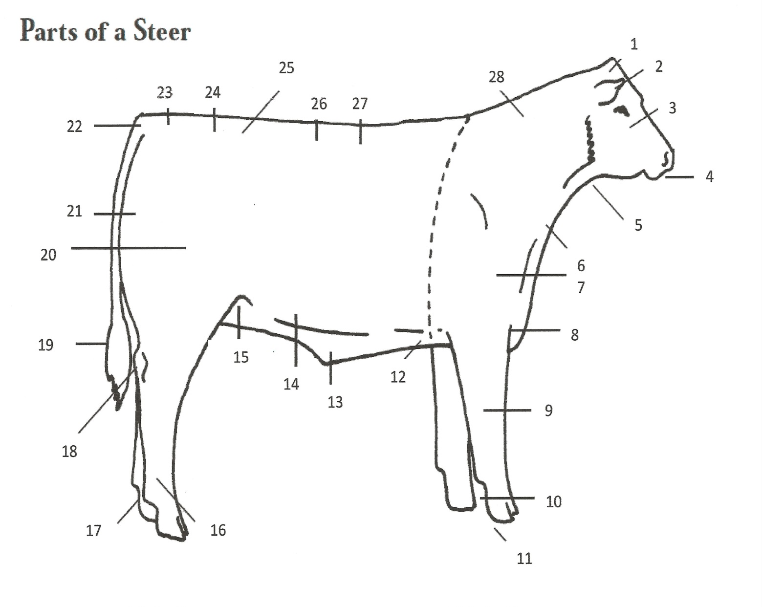

_____ Poll _____ Neck _____ Rump _____ Belly or Middle
_____ Face _____ Loin _____ Hoof
_____ Quarter or
_____ Throat _____ Pins _____ Muzzle Round

_____ Brisket _____ Switch _____ Dew Claw _____ Cannon Bone

_____ Knee _____ Back _____ Stifle _____ Tail Head

_____ Sheath _____ Hock _____ Hooks _____ Rear Flank

_____ Pastern _____ Ear _____ Dewlap _____ Point of
Shoulder
_____ Heart Girth

Write the Letter from Below Next to the Correct Beef Part Above

A. BACK B. BRISKET C. CREST

D. DEWCLAW E. DEWLAP F. EAR

G. FACE H. FOREARM I. HEART GIRTH

J. HOCK K. HOOF L. HOOK

M. KNEE N. LOIN O. MUZZLE
P. PASTERN Q. PIN R. POINT OF SHOULDER

S. POLL T. QUARTER U. RUMP

V. SWITCH W. TAIL HEAD X. THROAT
Write the Letter from Below Next to the Correct Beef Part Above

A. BACK B. BRISKET C. CREST

D. DEWCLAW E. DEWLAP F. EAR

G. FACE H. FOREARM I. HEART GIRTH

J. HOCK K. HOOF L. HOOK

M. KNEE N. LOIN O. MUZZLE
P. PASTERN Q. PIN R. POINT OF SHOULDER

S. POLL T. QUARTER U. RUMP

V. SWITCH W. TAIL HEAD X. THROAT

2024- Small Market Feeder Calf (8 & up) PAGE 9

(Ages 8 do this page)
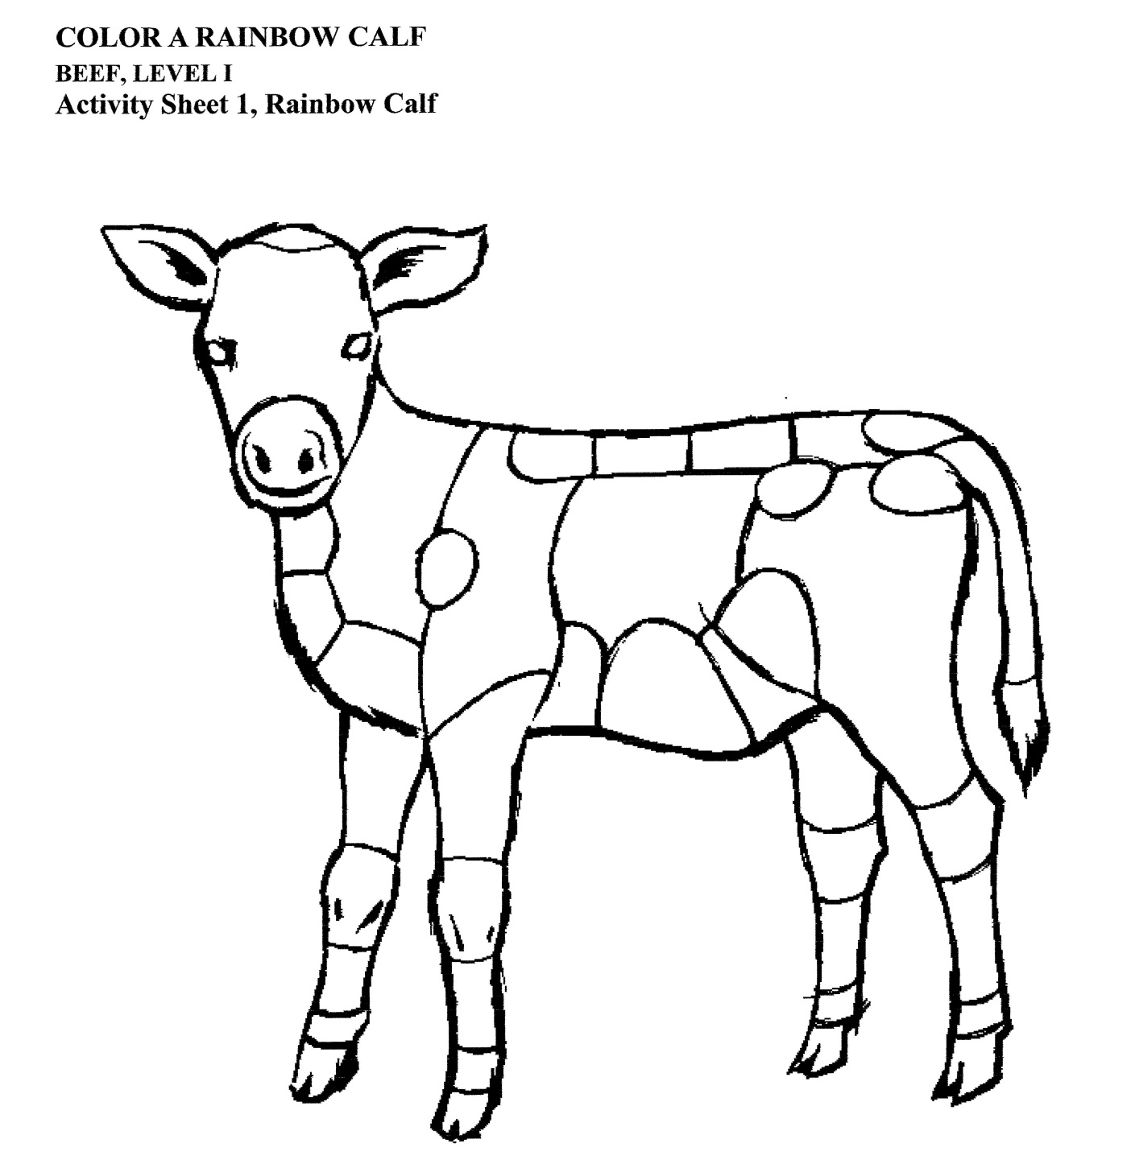
IDENTIFY THE PARTS OF THE FEEDER CALF BY COLORING THE PARTS AS LISTED BELOW:

1. Poll- Orange 12. Heart Girth- Red 23. Hooks- Blue
2. Ear- Pink 13. Belly or Middle- Pink 24. Loin- Red
3. Face- Purple 14. Rear Flank- Green 25. Back- Orange
4. Muzzle- Green 15. Hock- Purple 26. Ribs- Purple
5. Throat- Yellow 16. Cannon Bone- Blue 27. Tail- Blue
6. Dewlap- Red 17. Stifle- Blue 28. Crops- Purple
7. Point of Shoulder- Orange 18. Switch- Pink 29. Shoulder- Pink
8. Brisket- Blue 19. Quarter or Round- Red 30. Neck- Brown
9. Knee- Purple 20. Tail Head- Yellow 31. Forearm- Orange
10. Pastern- Yellow 21. Pins- Green 32. Eye- Brown
11. Hoof- Orange 22. Rump- Brown
Courtesy of Kansas State University, Beef Leader Notebook

2024- Small Market Feeder Calf (8 & up) PAGE 9
WHOLESALE CUTS OF BEEF
2024- Small Market Feeder Calf (8 & up) PAGE 10

Write the letter on the line that lists the correct part.
A. BRISKET
B. CHUCK
C. FLANK
D. FORE SHANK
E. RIB
F. ROUND
G. SHORT LOIN
H. SHORT PLATE
I. SIRLOIN

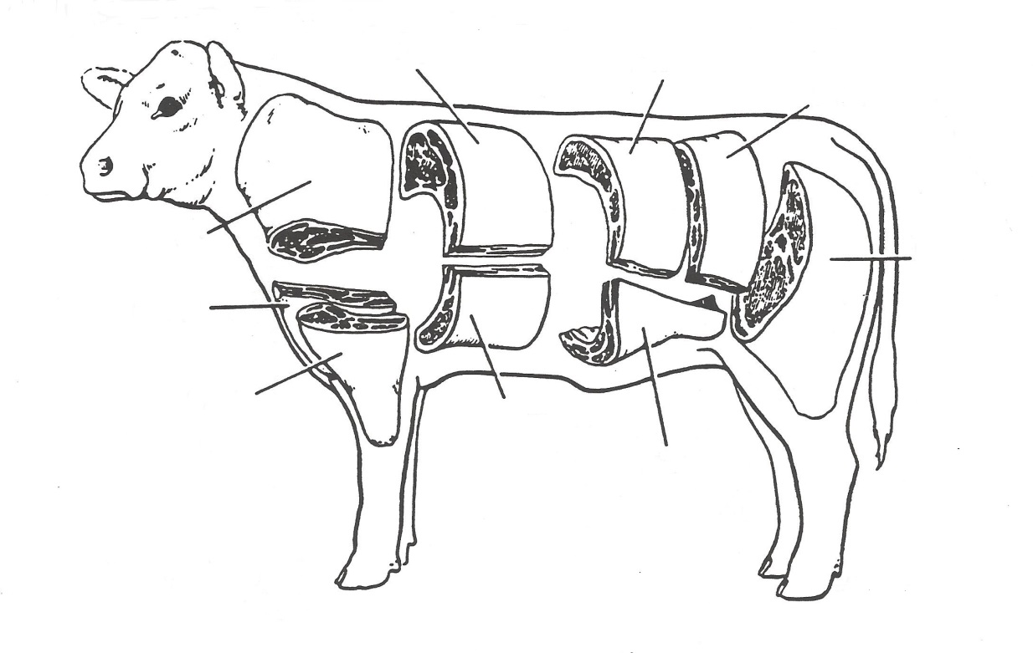
FILL IN THE RETAIL CUTS OF BEEF USING THE WORDS IN THE WORD BANK

WORD BANK
BRISKET RUMP ROAST
FLANK STEAK STEW BEEF
ROUND STEAK RIB STEAK
SHORT RIBS SIRLOIN STEAK
CHUCK ROAST T-BONE STEAK
GROUND BEEF

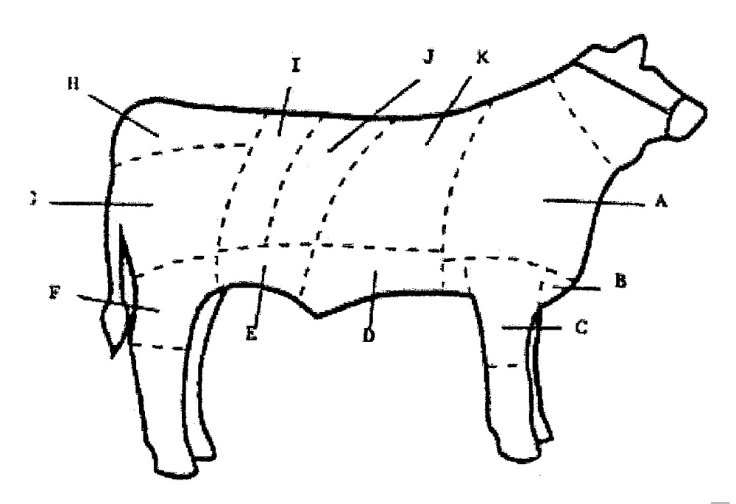
K
J
IG
A
B
C
D
E
F
G
H
A. ___________________ D. ___________________ G.___________________ J. __________________
B.___________________ E. ___________________ H. ___________________ K. __________________
C. ___________________ F. ___________________ I. ___________________

2024- Small Market Feeder Calf (8 & up) PAGE 11

NUTRIENTS - find the following nutrients for your calf by circling the words in the puzzle below, they may be up, down forward or backwards
WORD BANK
- Corn
- Energy
- Forage
- Grains
- Hay
- Minerals
- Protein
- Roughage
- Vitamins
- Water
W | I | R | M | U | E | G | A | E | H | S | V | T | O | M | L
E | M | D | O | N | V | I | T | A | M | I | N | S | I | S | N
T | I | E | R | I | G | R | R | R | O | H | I | N | T | U | R
H | N | R | E | R | E | T | A | W | C | E | L | I | I | E | O
E | E | T | P | O | O | E | T | C | T | L | M | A | G | X | C
P | R | O | E | N | E | G | A | H | G | U | O | R | E | T | A
E | A | F | R | G | N | E | Y | A | A | P | T | G | R | E | K
O | L | O | F | O | E | N | S | L | P | U | D | R | S | N | E
P | S | R | E | B | R | S | U | F | O | R | A | G | E | A | G
L | N | M | C | L | G | P | P | A | U | S | E | P | B | Q | Z
E | O | A | T | U | Y | A | H | P | P | R | O | T | E | I | N

SHOW BOX SUPPLIES
____ Adhesive A. Used for applying any liquid hair preparation
____ Scotch Comb B. Dressier appearing halter for the showring
____ Flathead Clippers C. Used to hold the calf’s hair in place
____ Show Halter D. Used to pick manure up out of the stall
____ Spray Bottle E. Used to style the calf’s hair
____ Stall Fork F. Used for clipping when a shaved look is desired
____ Show Stick G. Used for setting the calf’s feet & calming the animal in the showring.

2024- Small Market Feeder Calf (8 & up) PAGE 12

BREEDS
(match the breeds by writing in the correct letter on the line that matches the definition)

____ BRAHAM A. Large frame, solid white breed from France. They are known for their fast growth rates.

____ CHAROLAIS B. Large muscled, red to gold breed from the French region of Limousin and Marche.

____ CHIANINA C. Solid black polled breed. Most numerous cattle in the US. Originated in Scotland.

___ HEREFORD D. White faced, red cattle. Known for their mothering & foraging Second most numerous breed in the US. ability plus their very docile disposition.

___ SIMMENTAL E. Developed in a cold, rocky, harsh environment this breed’s important traits are small frame size, calving
ease and cold weather tolerance.

___ LIMOUSIN F. Developed as a draft animal, the most important traits are extreme size & strength. They are the largest cattle in the world.

__ ANGUS G. White faced, red or yellow breed from Simme Valley Switzerland. Noted for good milk production. American versions are black or red with a blazed face.

____ SOUTH HIGHLAND H. Developed in a hot environment this breed’s important traits are disease resistance, heat & tolerance hardiness.

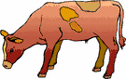

2024- Small Market Feeder Calf (8 & up) PAGE 13

S | U | P | P | O | L | L | E | D | G | O | R | P | Z | B
H | W | P | M | G | O | B | L | U | E | Z | E | A | N | E
A | P | A | S | P | A | R | T | Y | H | A | T | D | H | E
M | A | S | E | V | O | O | H | F | G | R | A | S | S | F
B | S | T | G | O | G | R | E | E | N | O | W | T | I | B
U | R | U | M | I | N | A | N | T | A | L | L | H | N | A
R | S | R | B | E | I | E | C | O | M | Z | Q | P | I | L
G | K | E | Z | B | A | J | C | N | M | C | A | L | F | P
E | L | O | L | Q | R | U | C | Z | M | O | K | Y | U | F
R | B | S | D | A | G | R | I | C | U | L | T | U | R | E
C | U | L | T | U | R | M | Z | F | L | O | G | J | E | E
E | L | M | O | C | B | I | G | B | I | S | R | D | A | D
N | P | R | O | T | E | I | N | G | S | T | E | A | K | R
O | V | E | R | I | O | N | Q | U | M | R | G | Y | H | R
P | L | A | Y | O | T | H | E | G | A | U | M | E | T | I
U | V | X | E | N | R | A | B | B | A | M | R | N | E | Y
I | S | A | D | I | N | Y | O | S | A | U | R | F | Z | V
S | T | R | A | W | T | A | O | L | B | S | T | E | E | R

FIND THE CATTLE WORDS ABOVE
(may be forward, backward, up or down) Make sure you know what the words mean, if you do not then ask your leader, parent, older youth leader, etc.)

AGRICULTURE PASTURE BARN
HOOVES COLOSTRUM FINISH
BEEF WATER FEED
CALF GRASS RUMINANT
GRAIN PROTEIN POLLED
HAY STEER WARTS
STEAK AUCTION HAMBURGER

2024- Small Market Feeder Calf (8 & up) PAGE 14

ANSWER THE FOLLOWING QUESTIONS:

- Why did you pick the steer that you picked? ______________________________________________

____________________________________________________________________________________

____________________________________________________________________________________

____________________________________________________________________________________

- What is the best feature(s) of your market steer?______________________________________

____________________________________________________________________________________

____________________________________________________________________________________

____________________________________________________________________________________

- What feature(s) of your market steer could use improvement? _____________________

____________________________________________________________________________________

____________________________________________________________________________________

____________________________________________________________________________________

- Will you do a feeder calf project again? _____________________ Why or why not?

____________________________________________________________________________________

_____________________________________________________________________________________

_____________________________________________________________________________________

_____________________________________________________________________________________

2024- Small Market Feeder Calf (8 & up) Page 15

The 4-H Pledge
Complete the Pledge
I Pledge:
My HEAD to clearer ______________________________,
My HEART to greater ______________________________,
My HANDS to larger ________________________________, and
My HEALTH to better ________________________________,
For my __________________________, my ____________________,
My __________________________, and my _________________________.

The 4-H Mottos is: ______________________________________.

4-H ACTIVITIES

Number of club meetings held: __________ Number you attended: _________

List any club activities in which you have:
- participated in
- responsibilities which you have assumed

(for example: Community service events, workshops, judging contest, clinics, offices held, parades representing 4-H, etc., if none, write none)

Activity | Date | Location | Placing, Position or Comments

2024- Small Market Feeder Calf (8 & up) Page 16

MY 4-H STORY

Interesting things that happened to me and my animal this year, challenges, highlights of my year or anything else I would like to share about my overall 4-H experience.

POTENTIAL BUYERS NAMES

As part of your 4-H Small Market Livestock Project, you must personally contact at least three potential buyers before the Oceana County Fair. You are encouraged to seek two new buyers that have not been asked or submitted before. You also must have at least three different buyers than those of your siblings in the market livestock project. Please confirm with your buyers their accurate mailing address (example: post office box vs. a street address). The information on page 16 must be completed and taken to the Oceana County MSU Extension Office on or before the due date where it will be copied and used to send out letters to your potential buyers. This page will remain in your notebooks. This is a Market Livestock Committee rule. Failure to comply will result in not being able to sell your animal in the 4-H Market Livestock Sale.

2024- Young Beef and Feeder Calf Record Book Staff _________________
Page 17 Date ________________
SMALL MARKET POTENTIAL BUYER’S LIST
FEEDER CALF PROJECT (AGES 8 & up)

Name______________________________ Club_________________________
Please print business names and complete addresses clearly.

  - Contact Name ____________________________________________________

Business Name ____________________________________________________

Mailing Address _________________________City_________________Zip_____

Phone _______________________ After Hours Phone______________________
Mailing Preference (Please Check One): Email ____ Postal Delivery ____

Email ____________________________________________________________

Signature__________________________________________________________

2. Contact Name ____________________________________________________

Business Name ____________________________________________________

Mailing Address _________________________City_________________Zip_____

Phone _______________________ After Hours Phone______________________
Mailing Preference (Please Check One): Email ____ Postal Delivery ____

Email ____________________________________________________________

Signature__________________________________________________________

3. Contact Name ____________________________________________________

Business Name ____________________________________________________

Mailing Address _________________________City_________________Zip_____

Phone _______________________ After Hours Phone______________________
Mailing Preference (Please Check One): Email ____ Postal Delivery ____

Email ____________________________________________________________

Signature__________________________________________________________

(Must be stamped by the MSU Extension Office)
2024- Small Market Feeder Calf (8 & up) Page 18

PICTURES OF YOUR PROJECT

(Please use this page for your project pictures. Add additional pages if you would like. The judges appreciate captions or labels with your pictures
to know what the picture is about.)

CLUB POINTS
JUNIOR MARKET/SMALL ANIMAL ASSOCIATION PROJECT
ATTENDANCE RECORD

MEETING NAME | LOCATION | DATE | POINTS | SIGNATURE OF LEADER
Please note: This form must be included with your record notebook and turned into the weigh master on entry day of the Fair. You need to accumulate nine (9) points to be allowed to sell your animal. Six (6) of these nine (9) points must come from club meetings. Three (3) nonclub points must come from other types of meetings (example: clinics, shows, workshops, fair clean-up and/or county-wide awards).

NON-CLUB POINTS

JUNIOR MARKET/SMALL MARKET ANIMAL ASSOCATION PROJECT
ATTENDANCE RECORD
(this must be filled out when presenting for signatures at the office

MEETING NAME | LOCATION | DATE | POINTS | SIGNATURE OF LEADER, SUPERINTENDENT OR MSU STAFF
Please note: This form must be included with your record notebook and turned into the weigh master on entry day of the Fair. You need to accumulate nine (9) points to be allowed to sell your animal. Six (6) of these nine (9) points must come from club meetings. Three (3) nonclub points must come from other types of meetings (example: clinics, shows, workshops, fair clean-up and/or county-wide awards).

